Sprite processing V 0.3

- Import files to UFO Analyzer (*.avi, *.jpg, *.xml, *.bmp)

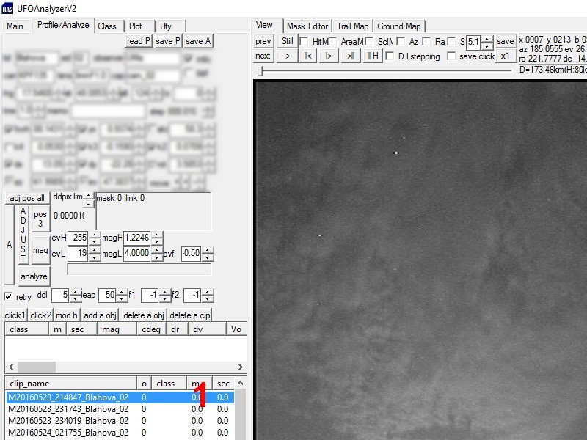
- Choose the Profile/Analyze tab

- Click the first clip (1)
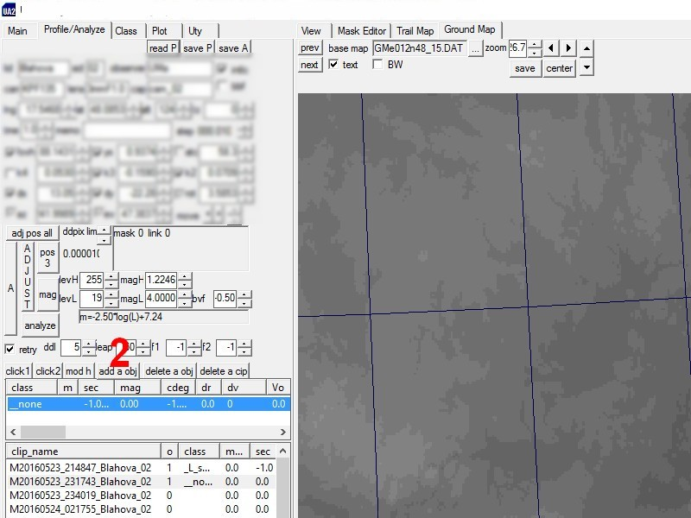
- Click the add a obj button (2)
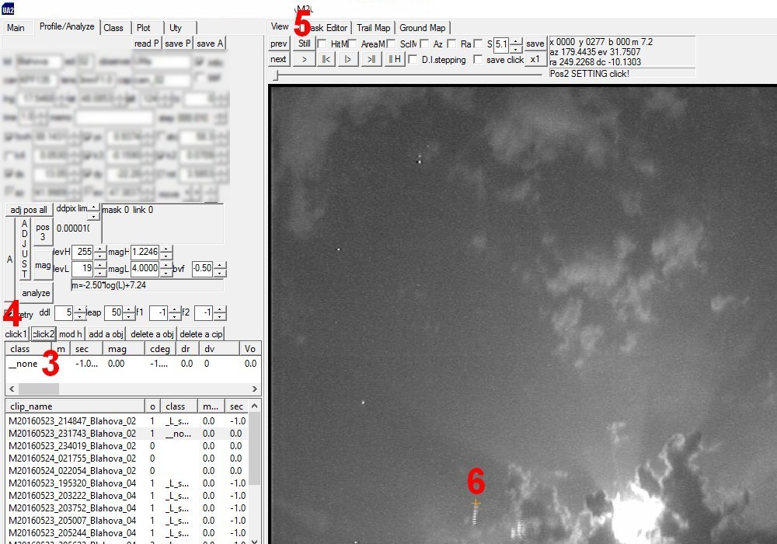
- Click the new object (3) then to the click 1 button (4)

- In the chosen View tab (5) click the upper edge of the sprite (6)

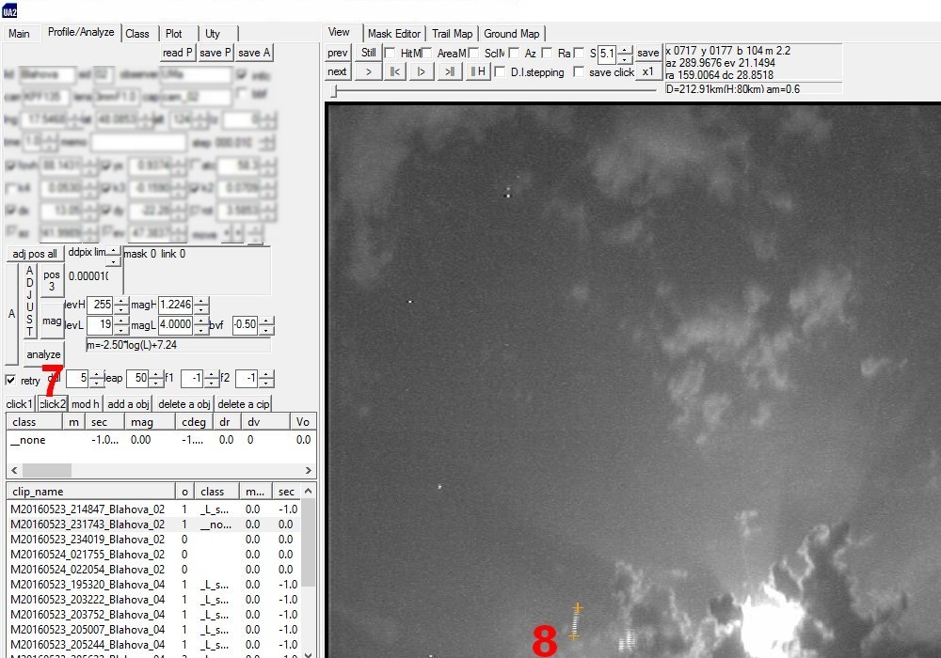

- Click the click 2 button (7) and click the sprite’s bottom edge (8)

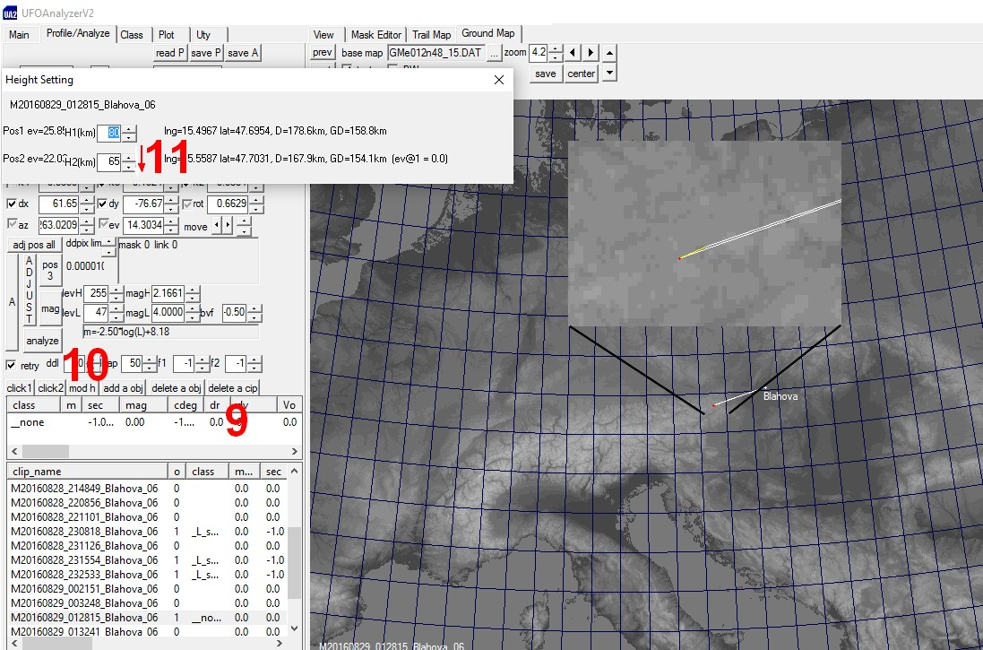

- Click the processed object (9) then the mod h button (10). In the opened Height Setting box live the H1 value on the default 80 km and change the H2 value (11) to achieve the shortest yellow line. Usually it has to be decreased.

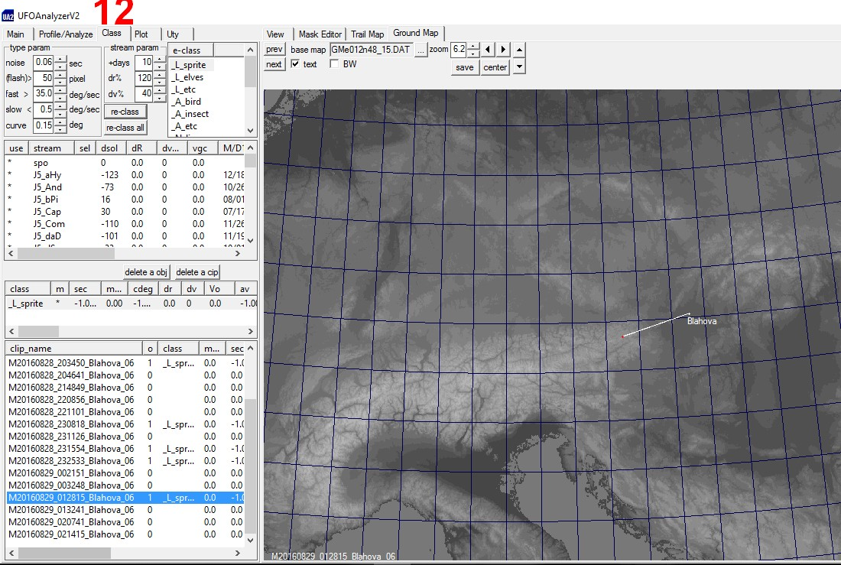

- Click the Class tab (12) and choose the object type from the e-class list.

- Repeat the process for all observations

- When all observations are processed choose the Uty tab (10)

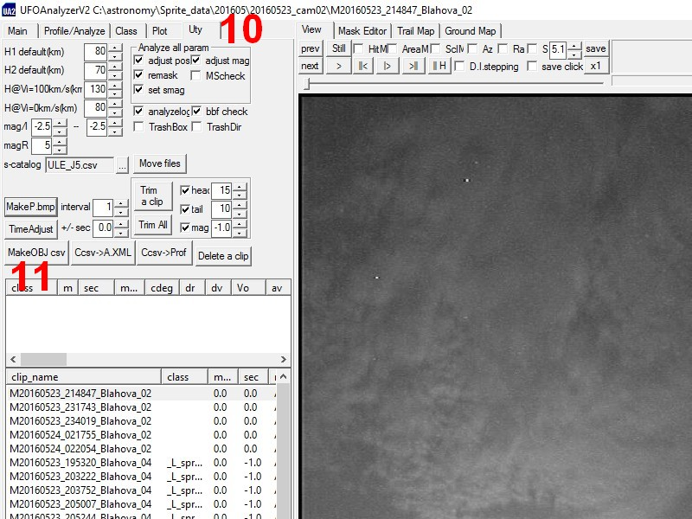
- Click the MakeOBJ csv button (11)

